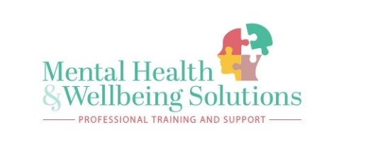
Mental Health and Wellbeing Solutions
Award in Counselling Concepts (Level 2)
I wish to apply for a place on the following course:
Award in Counselling Concepts (Level 2) | Day / Time  Tuesday 6pm -9pm | Mental Health and Wellbeing Solutions | 10 Weeks | Commencing  20/10/2020

Once we have received your completed application form, we will get in touch with you to arrange, a telephone interview. This will be informal with 5 questions asked. Please note you must attend the telephone interview in order to be offered a place on the course. After we have offered you a place on the course, we will not write to you again unless we have any further queries with your application. The induction onto the course will be held on the first taught session, 20/10/2020. Please arrive on time to the venue in order we can make a prompt start at 6pm. Parking is available on site. We look forward to seeing you and getting you started on your Counselling Level 2 journey.
Name:
Address: | …………………………………………………………………………………………..  …………………………………………………………………………………………..  …………………………………………………………………………………………..
Email Address
Telephone no. | Home/Mobile
Please circle your age group (noting that, because of the nature of the course, those under 21 years of age will not be considered).
21-24 years please specify – 21 22 23 24
25-30 years | 31-60 years | Over 60 years

Current Occupation

Why do you want to study on this course? Outline your motives and reasons clearly Please use the reverse of this form for additional space.
…………………………………………………………………………………………………………………………………………………………………………………

…………………………………………………………………………………………………………………………………………………………………………………

……………………………………………………………………………………………………………………………………………………………………………………

I understand that I may be asked to discuss my application, for example personal issues; that I need to attend for at least 80% of the course, and that it is essential to attend the first session of the course.
Signature: | Date:

Please return completed form to Wendy Fielding - Director,
Wendy@mhwsolutions.co.uk electronic signature will be accepted when email is sent from your personal email account.
We would appreciate confirmation of your intention to accept the place offered on the course by 13/10/20 for any other information please phone 07776 - 912631 or 07735 - 498348

