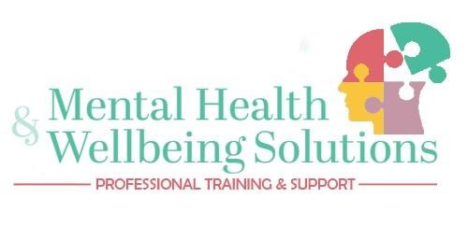

**Become Mental Health Aware (MHFA) – 1/2 day**

**Course Overview:**

Mental Health First Aid (MHFA) England has developed evidence-based courses which are grounded in research and have been rigorously tested. The purpose of the courses is to raise awareness of mental health issues, reduce the stigma surrounding mental health and to empower people with the knowledge and skills required to support those who are in need.

This introductory course raises awareness of mental health, learners will have:

* An understanding of what mental health is and how to challenge stigma
* A basic knowledge of some common mental health issues
* An introduction to looking after their own mental health and maintaining wellbeing
* Confidence to offer support someone in distress or who may be experiencing a mental health issue

**Course Requirements:**

The MHFA England courses are suitable for those who have an interest in mental health and wellbeing and who want to be a part of reducing the stigma attached to mental health issues.

**Course Assessment:**

The courses are not formally assessed; however, delegates are expected to actively participate during the day. On completion a Youth Mental Health Awareness certificate will be awarded.

Everyone who completes the course will be provided with:

* A manual to refer to whenever you need it
* A workbook including a helpful toolkit to support your own mental health

**Cost:**

£100 per delegate, corporate bundle rates available.

**Contact us for advice, more information or to book a course:**

Or you can visit our website www.mhwsolutions.co.uk

Email us at enquiries@mhwsolutions.co.uk

Call us on 07776 912631 or 07735 498348